Lab # 9

Method Overriding & polymorphism

OBJECTive:
To study Method Overriding and polymorphism.

THEORY:

9.1 OVERRIDING A BASE CLASS METHOD

You can define a method in a derived class that has the same signature as a method in the base class. The access attribute for the method in the derived class can be the same as that in the base class or less restrictive, but it cannot be more restrictive. As shown in the figure.

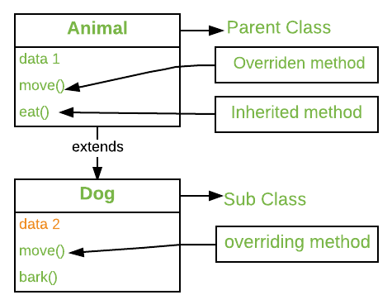

This means that if you declare a method as public in the base class, for example, any derived class definition of the method must also be declared as public. You cannot omit the access attribute in the derived class in this case, or specify it as private or protected. When you define a new version of a base class method in this way, the derived class method will be called for a derived class object, not the method inherited from the base class. The method in the derived class overrides the method in the base class. The base class method is still there though, and it is still possible to call it in a derived class. Let’s see an overriding method in a derived class in action.

// Method overriding.
class A {
int i, j;
A(int a, int b) {
i = a;
j = b;
}
// display i and j
void show() {
System.out.println("i and j: " + i + " " + j);
}
}
class B extends A {
int k;
B(int a, int b, int c) {
super(a, b);
k = c;
}
// display k – this overrides show() in A
void show() {
System.out.println("k: " + k);
}
}
class Override {
public static void main(String args[]) {
B subOb = new B(1, 2, 3);
subOb.show(); // this calls show() in B
}
}

Output:

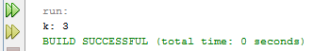

When show( ) is invoked on an object of type B, the version of show( ) defined within B is used. That is, the version of show( ) inside B overrides the version declared in A.

If you wish to access the superclass version of an overridden function, you can do so by using super. For example, in this version of B, the superclass version of show( ) is invoked within the subclass’ version. This allows all instance variables to be displayed.

class B extends A {
int k;
B(int a, int b, int c) {
super(a, b);
k = c;
}
void show() {
super.show(); // this calls A's show()
System.out.println("k: " + k);
}
}
If you substitute this version of A into the previous program, you will see the following output:

Output
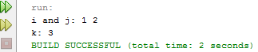

9.2 POLYMORPHISM

Class inheritance is not just about reusing classes that you have already defined as a basis for defining a new class. It also adds enormous flexibility to the way in which you can program your applications, with a mechanism called polymorphism. So what is polymorphism? The word polymorphism generally means the ability to assume several different forms or shapes. In programming terms it means the ability of a single variable of a given type to be used to reference objects of different types and to automatically call the method that is specific to the type of object the variable references. This enables a single method call to behave differently, depending on the type of the object to which the call applies. This is illustrated in Figure.

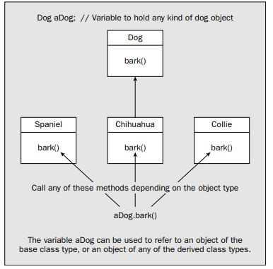

Polymorphism describes a language’s ability to process objects of various types and classes through a single, uniform interface.
Polymorphism in Java has two types: Compile time polymorphism (static binding) and Runtime polymorphism (dynamic binding). Method overloading is an example of static polymorphism, while method overriding is an example of dynamic polymorphism.
Polymorphism is the ability of an object to take on many forms. The most common use of polymorphism in OOP occurs when a parent class reference is used to refer to a child class object.

LAB TASK

- Create a class Card, and its children classes are Valentine, Holiday, and Birthday. A card class will have a greeting () method that writes out a greeting. Each type of card contains an appropriate greeting. The Holiday card says "Season's Greetings." The Birthday card says "Happy Birthday." The Eid card says "Happy blissful Eid". Create objects of the three child classes: Holiday, Birthday and Eid and show the polymorphic behavior (call the greeting methods from each object).

- Create a super class called Car. The Car class has the following fields and methods. int speed; double regularPrice; String color; double getSalePrice(); Create a sub class of Car class and name it as Truck.
The Truck class has the following fields and methods.int weight; doublegetSalePrice();//Ifweight>2000,10%discount.Otherwise,20%discount. Create a subclass of Car class and name it as Ford. The Ford class has the following fields and methods. int year; int manufacturerDiscount; double getSalePrice();//From the sale price computed from Car class, subtract the manufacturer Discount. Create MyOwnAutoShop class which contains the main() method. Perform the following within the main() method. Create two instances of the Ford and Truck class and initialize all the fields with appropriate values. Use super(...) method in the constructor for initializing the fields of the super class. Create an instance of Car class and initialize all the fields with appropriate values. Display the sale prices of all instance. Show polymorphic behavior.

Assignment
- Is constructor overloading polymorphism? If Yes or No, Justify your Answer.
- Figure out the type of polymorphism is method overloading and method overriding respectively.

